Spaghetti Dinner
(Spaghetti,Salad,Dessert, and Drink)
January 30th Underwood High School
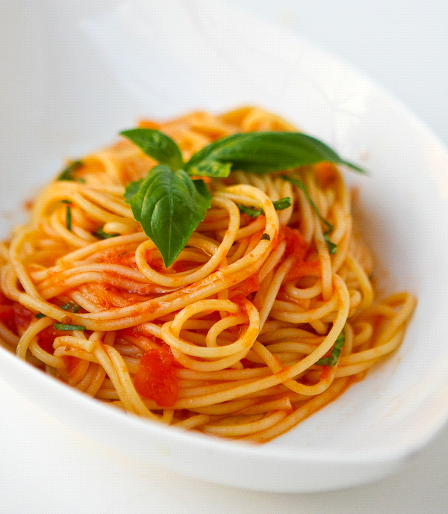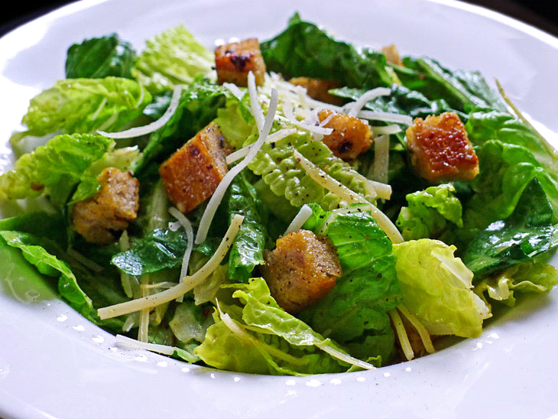
4:00-7:00 During the Tri-Center Trojans vs Underwood Eagles Basketball Game!!!!
$5.00 dinner
Proceeds benefit Post Prom Activities

